**Fitness Tracking System**

**Mini Project 2 B Report**

Submitted in partial fulfillment of the requirement of University of Mumbai

For the Degree of

**(Computer Engineering)**

**By**

1. **Piyush Kadu “ID No: TU3F2223094”**

**2) Pranjal Bhatt “ID No: TU3F2223089”**

**3) Sidhi Bandsode “ID No: TU3F2223102”**

**Under the Guidance of**

**Prof. Priti Patil**



**Department of Computer Engineering**

**TERNA ENGINEERING COLLEGE**

**Plot no.12, Sector-22, Opp. Nerul Railway station,**

**Phase-11, Nerul (w), Navi Mumbai 400706**

**UNIVERSITY OF MUMBAI**



**TERNA ENGINEERING COLLEGE, NERUL,**

**NAVI MUMBAI**

**Department of Computer Engineering**

Academic Year 2024-25

**CERTIFICATE**

This is to certify that the mini project 2 B entitles “Fitness Tracker System” is a bonafide work of

1. **Piyush Kadu “ID No: TU3F2223094”**

**2) Pranjal Bhatt “ID No: TU3F2223089”**

**3) Sidhi Bandsode “ID No: TU3F2223102”**

submitted to the University of Mumbai in partial fulfillment of the requirement for the award of the Bachelor of Engineering (Computer Engineering).

**Guide Head of Department Principal**

**Project Report Approval**

This Mini Project 2B Report – entitled “**Fitness Tracker System**” by following students is approved for the degree of ***T.E. in "Computer Engineering"***.

**Submitted by:**

1. **Piyush Kadu “ID No: TU3F2223094”**

**2) Pranjal Bhatt “ID No: TU3F2223089”**

**3) Sidhi Bandsode “ID No: TU3F2223102”**

Examiners Name & Signature:

1.---------------------------------------------------------

2.----------------------------------------------------------

Date: ------------------------------

Place: ---------------------------------

**Declaration**

We declare that this written submission represents our ideas in our own words and where others' ideas or words have been included, we have adequately cited and referenced the original sources. We also declare that we have adhered to all principles of academic honesty and integrity and have not misrepresented or fabricated or falsified any idea/data/fact/source in our submission. We understand that any violation of the above will be cause for disciplinary action by the Institute and can also evoke penal action from the sources which have thus not been properly cited or from whom proper permission has not been taken when needed.

|  |  |  |
| --- | --- | --- |
| **Piyush Kadu** | **“ID No: TU3F2223094”** | --------------------------- |
| **Pranjal Bhatt** | **“ID No: TU3F2223089”** | --------------------------- |
| **Siddhi Bandsode** | **“ID No: TU3F2223102”** | --------------------------- |

Date: _____________________

Place: _____________________

**Acknowledgement**

We would like to express our sincere gratitude towards our guide **Prof. Priti Patil** Mini Project Coordinators **Prof. Siddharth Hariharan Coordinator** for their help, guidance and encouragement, they provided during the project development. This work would have not been possible without their valuable time, patience and motivation. We thank them for making our stint thoroughly pleasant and enriching. It was great learning and an honor being their student.

We are deeply thankful to **Prof. Kishore Sakure (H.O.D Computer Department)** and entire team in the Computer Department. They supported us with scientific guidance, advice and encouragement, they were always helpful and enthusiastic and this inspired us in our work.

We take the privilege to express our sincere thanks to **Dr. L. K. Ragha**our Principal for providing the encouragement and much support throughout our work.

|  |  |  |
| --- | --- | --- |
| **Piyush Kadu** | **“ID No: TU3F2223094”** | --------------------------- |
| **Pranjal Bhatt** | **“ID No: TU3F2223089”** | --------------------------- |
| **Siddhi Bandsode** | **“ID No: TU3F2223102”** | --------------------------- |

Date: _____________________

Place: _____________________

**Index**

**TABLE OF CONTENT**

|  |  |  |
| --- | --- | --- |
| Sr. No | Title | Page No. |
| i | **Abstract** | 7 |
| ii | **List of Figures** | 8 |
| iii | **List of Tables** | 9 |
| Chapter 1 | Introduction   * 1. Aim   2. Motivation   3. Scope of project | 10 |
| Chapter 2 | Problem Statement | 11 |
| Chapter 3 | Literature Survey | 13 |
| Chapter 4 | Design and implementation | 15 |
| Chapter 5 | Results and Discussions | 18 |
| Chapter 6 | Conclusion and Future Scope | 24 |
|  | Reference | 25 |

## Abstract

The Fitness Tracking System is a comprehensive web-based platform developed to enhance user engagement and effectiveness in personal fitness management. Designed with a modern technology stack, React for the frontend, Spring Boot for the backend, and PostgreSQL for the database. It offers a responsive and user-friendly experience across devices. The system enables users to monitor their fitness progress through performance tracking, view virtual exercise demonstrations for consistent training.

A key goal of this system is to offer structured, personalized workout plans tailored to individual needs, whether the aim is weight loss, muscle gain, or maintaining a healthy lifestyle. The integration of intelligent features bridges the gap between conventional fitness tracking and advanced digital solutions, making the platform not only informative but also highly interactive. By combining functionality with user motivation tools, the system encourages sustainable health habits and empowers users to take control of their wellness journey. This project represents a step forward in leveraging technology to create smarter, more engaging fitness experiences.

**List of Figures**

|  |  |  |
| --- | --- | --- |
| **Sr. No.** | **Name of Figure** | **Page No.** |
| 1 | Flowchart | 15 |
| 2 | Use Case Diagram | 16 |
| 3 | Home Page | 18 |
| 4 | Ai Model | 20 |
| 5 | Sign In Page | 20 |
| 6 | Login Page | 21 |
| 7 | Profile Page | 22 |
| 8 | Exercise Guide | 23 |

**List of Tables**

|  |  |  |
| --- | --- | --- |
| **Sr. No.** | **Name of Table** | **Page No.** |
| 1 | Literature Survey | 13 |

**Chapter 1**

**Introduction**

**1.1 Aim:**

The aim of this project is to develop a comprehensive fitness tracking system that helps users effectively monitor and improve their physical health. By providing personalized workout plans, performance tracking, and interactive features such as virtual exercise demonstrations. The system empowers users to take control of their fitness journey. The platform is designed to cater to individual fitness goals, whether it’s weight loss, muscle building, or general wellness, through structured, goal-oriented plans. The project focuses on offering a seamless, user-friendly experience that encourages consistency, motivation, and long-term health improvements, bridging the gap between traditional fitness tracking methods and modern digital solutions.

**1.2 Motivation:**

As health and wellness become increasingly important in today’s fast-paced world, many individuals face challenges in maintaining a consistent fitness routine due to lack of motivation or proper guidance. Traditional fitness tracking can often be overwhelming, and personalized plans can be hard to navigate. This project aims to address these issues by providing an accessible, user-friendly platform that simplifies fitness management. By offering personalized workout plans, progress tracking, and interactive features, the system encourages users to stay consistent, helping them achieve long-term fitness goals and maintain a healthier lifestyle.

**1.3 Scope of the Project:**

The project involves the design and development of a comprehensive fitness tracking system that includes the following modules:

* **Performance Tracking**: To monitor user’s progress, including exercise completion and fitness milestones.
* **Personalized Workout Plans**: To generate customized workout routines based on user goals (e.g., strength, cardio, flexibility).
* **Virtual Exercise Demonstrations**: To provide visual guides for various exercises, ensuring proper form and technique.

The system will ensure an interactive and intuitive user experience, offering personalized features that adapt to different fitness levels and goals, fostering motivation, consistency, and long-term health improvements.

**Chapter 2**

**Problem Statement**

**2.1 Problem Statement**Many individuals struggle to maintain a consistent and effective fitness routine due to a lack of personalized guidance, inadequate tracking tools, and difficulty in accessing reliable resources. The challenge is to create a unified platform that integrates various fitness tools, such as workout planning, diet suggestions, and exercise guidance, to help users achieve their health and fitness goals. This project addresses the need for a comprehensive fitness tracking system that offers a one-stop solution for personalized fitness guidance, motivating users to adopt healthier lifestyles and achieve long-term well-being.

**2.2 Features**• Performance Tracking: To monitor user progress through workout completion and fitness milestones.  
• Personalized Workout Plans: To generate custom routines based on user goals (e.g., strength, cardio, flexibility).  
• Virtual Exercise Demonstrations: To provide visual guides on proper exercise form and technique.  
• Exercise Guide: To educate users on various exercises and correct techniques.  
• User-friendly Interface: To ensure seamless navigation for users of all levels.  
• Responsive Web Design: To deliver a smooth experience across different devices.

**2.3 Objectives**• To offer an easy-to-use performance tracking tool that helps users monitor their fitness progress and milestones.  
• To provide interactive virtual exercise demonstrations to ensure proper technique and safety during workouts.  
• To create a comprehensive exercise guide that educates users on a wide range of exercises, their benefits, and proper execution.• To encourage healthier habits and consistent training, helping users build sustainable fitness routines and achieve long-term wellness goals.

* 1. **Specifications of the System:**

• **Frontend**: React.js will be used to develop an interactive, responsive, and user-friendly interface. It will handle all features, including performance tracking, personalized workout plans, exercise demonstrations, and automated reminders.

• **Architecture**: A client-side web application where all features, calculations, and logic will be processed in the user's browser using JavaScript, ensuring fast and seamless interactions.

• **Storage**: PostgreSQL will be used for saving user preferormance and inputs during a session, ensuring data persistence with requiring a backend.

• **Platform**: The system will be web-based and accessible via all modern browsers, with no need for server-side processing or user login, offering a simple and efficient experience.

• **Design**: A clean and intuitive UI, developed with CSS, and React components, to facilitate easy navigation through various fitness tools and features.

**Chapter 3**

**Literature Review**

Table 3.1: Literature Survey

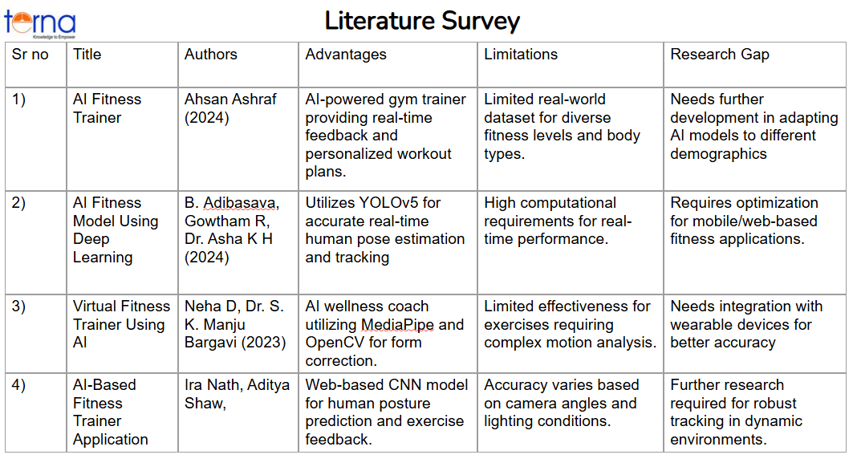

1. **AI Fitness Trainer (Ahsan Ashraf, 2024)**This paper discusses an AI-powered gym trainer that provides real-time feedback and personalized workout plans. The primary advantage of this approach is that it offers tailored guidance, enhancing the effectiveness of workouts. However, a significant limitation is the lack of a real-world dataset that includes diverse fitness levels and body types, which can hinder the system's ability to generalize across various user demographics. The research gap identified in this study lies in the need for further development in adapting AI models to different demographics, ensuring inclusivity and wider applicability.

**2) AI Fitness Model Using Deep Learning (B. Adibasava, Gowtham R,2024)**This research focuses on an AI fitness model that leverages YOLOv5 for accurate real-time human pose estimation and tracking. The advantage of this system is its precision in tracking movements, which allows for more accurate feedback on exercise form. However, one major limitation is the high computational requirements for real-time performance, which can be challenging for resource-constrained devices. The study **highlights a research gap that** requires optimization of the model for mobile and web-based fitness applications to make it more accessible to user3)s.

**3)Virtual Fitness Trainer Using AI (Neha D, Dr. S. K. Manju Bargavi, 2023)**This paper introduces an AI wellness coach that utilizes MediaPipe and OpenCV to offer form correction during exercises. The advantage of this system is its ability to provide real-time form corrections, helping users avoid injuries. Despite this, the system has limitations, particularly for exercises that involve complex motion analysis, where accuracy may diminish. The research gap identified here is the need for integration with wearable devices to improve accuracy and provide a more comprehensive fitness monitoring experience.

**4)AI-Based Fitness Trainer Application (Ira Nath, Aditya Shaw, 2024)**The study presents a web-based CNN model that predicts human posture and provides exercise feedback. The key advantage of this approach is its ability to offer real-time feedback on posture, which is crucial for improving exercise effectiveness. However, its accuracy varies based on camera angles and lighting conditions, making it less reliable in dynamic environments. The research gap identified in this study calls for further research to develop more robust tracking mechanisms that can work well under different environmental conditions.

**Chapter 4**

**Design and Implementation**

**4.1 Flowchart:**

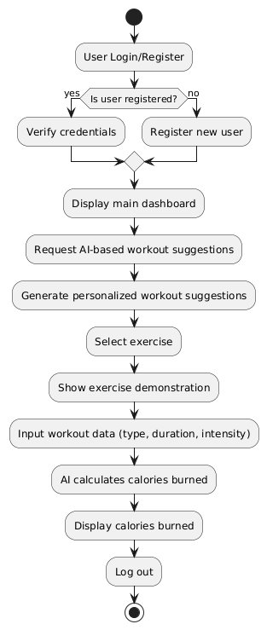

Fig 4.1 Flowchart

This flowchart outlines the structure and functionality of a **Fitness Tracker System**. Here's a short description:

The process starts with the user visiting the fitness website, which offers three main options:

1. **BMI Calculation** – Users can calculate their Body Mass Index.
2. **Caloric Needs** – Users input their age, height, weight, and activity level to receive their caloric needs, which can then branch into:
   * **Diet Plan** – Suggests meals based on the user’s data.
   * **Workout Plan** – Users select a goal (weight gain or loss) and receive a daily/weekly workout plan.
3. **FAQ** – Users can view common questions and answers for more information.

**4.2 Use Case Diagram:**

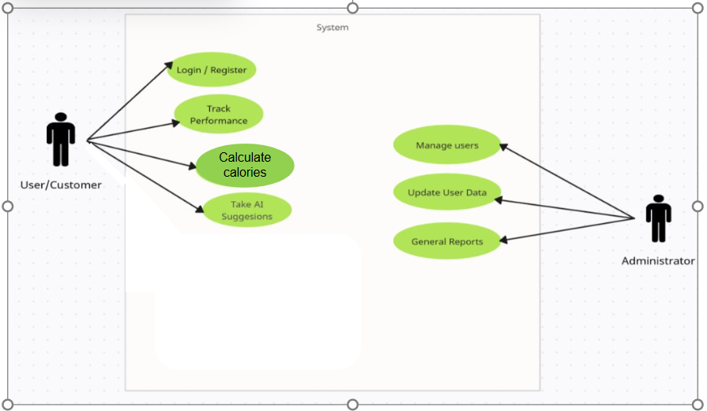

Fig 4.2 Use Case Diagram

1. Actor:

User: The primary actor interacting with the system. This could represent Components of the Use Case Diagram

* + individual seeking fitness/health guidance.

1. **Relationships:**

The **User** is connected to **all FOUR use cases** via associations (direct lines), indicating they can initiate each functionality.

**4.3 Hardware and Software Requirements:**

Hardware Requirements:

* Processor: Intel Core i3 or equivalent (minimum), Core i5 or higher recommended for optimal performance.
* RAM: 4GB (minimum), 8GB or more recommended.
* Storage: 500MB free disk space (minimum) for the application and related data.

Software Requirements:

* Visual Studio Code

Languages:

* CSS
* JavaScript
* React
* Python
* Java
* Spring And SpringBoot

**Chapter 5**

**Results and Discussions**

**5.1 Home Page:**

This is the home page of **GYM**, a fitness and health guidance platform. It offers tools and information to help users improve their sports experience. Key features include:

* Plans
* My workouts
* My Details
* Exercise guide

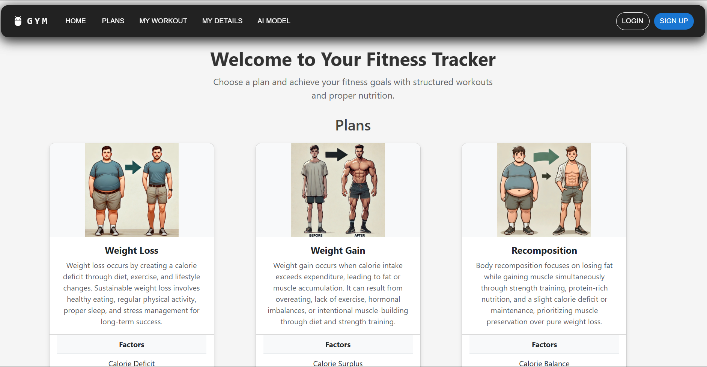

Fig 5.1: Home Page

**5.2 Ai Model:**

Welcome to the AI-Based Workout Generator section of the gym website. This tool uses your height (in centimeters), weight (in kilograms), and age (in years) to calculate your Body Mass Index (BMI). Based on your BMI and age, the AI model will recommend personalized workouts tailored to your fitness goals—whether you're looking to gain weight, maintain your current weight, or lose weight.

**AI Model Categories and Suggested Workouts**

* Underweight (BMI < 18.5)
  + Goal: Gain weight
  + If your BMI is less than 18.5, the model categorizes you as underweight. To promote healthy weight gain, the focus will be on strength training to build muscle mass and a higher-calorie intake.
  + **Recommended Workouts:**
    - Full-body resistance training (squats, deadlifts, bench press).
    - Compound exercises targeting large muscle groups (legs, chest, back).
    - Limited low-intensity cardio to avoid excessive calorie burn.
* **Normal Weight (18.5 ≤ BMI < 24.9)**
  + Goal: Maintain weight
  + If your BMI is between 18.5 and 24.9, the model classifies you as having a normal weight. The workout plan should help you maintain your weight while keeping your fitness balanced through a combination of strength, cardio, and flexibility training.
  + **Recommended Workouts:**
    - Full-body strength training (moderate weight, high repetitions).
    - Cardiovascular exercises (running, cycling, swimming).
    - Yoga or stretching sessions to improve flexibility and reduce stress.
* **Overweight (BMI ≥ 24.9)**
  + Goal: Lose weight
  + If your BMI is 24.9 or higher, the model categorizes you as overweight. The focus will be on fat-burning exercises, including high-intensity interval training (HIIT), cardio, and strength training to burn fat and increase lean muscle mass.
  + **Recommended Workouts:**
    - High-intensity interval training (HIIT) (circuit training, sprints).
    - Strength training to target large muscle groups.
    - Low-intensity cardio (walking, light cycling) to build endurance.

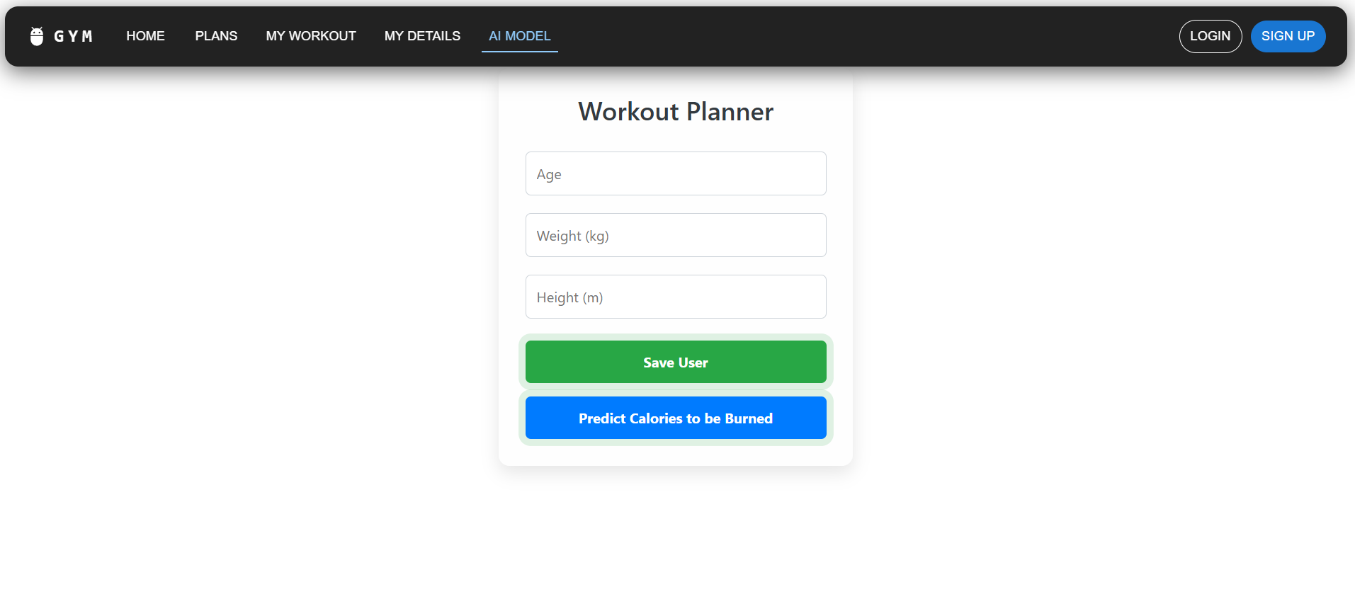

Fig 5.2: Ai Model

**5.3 Sign In page:**

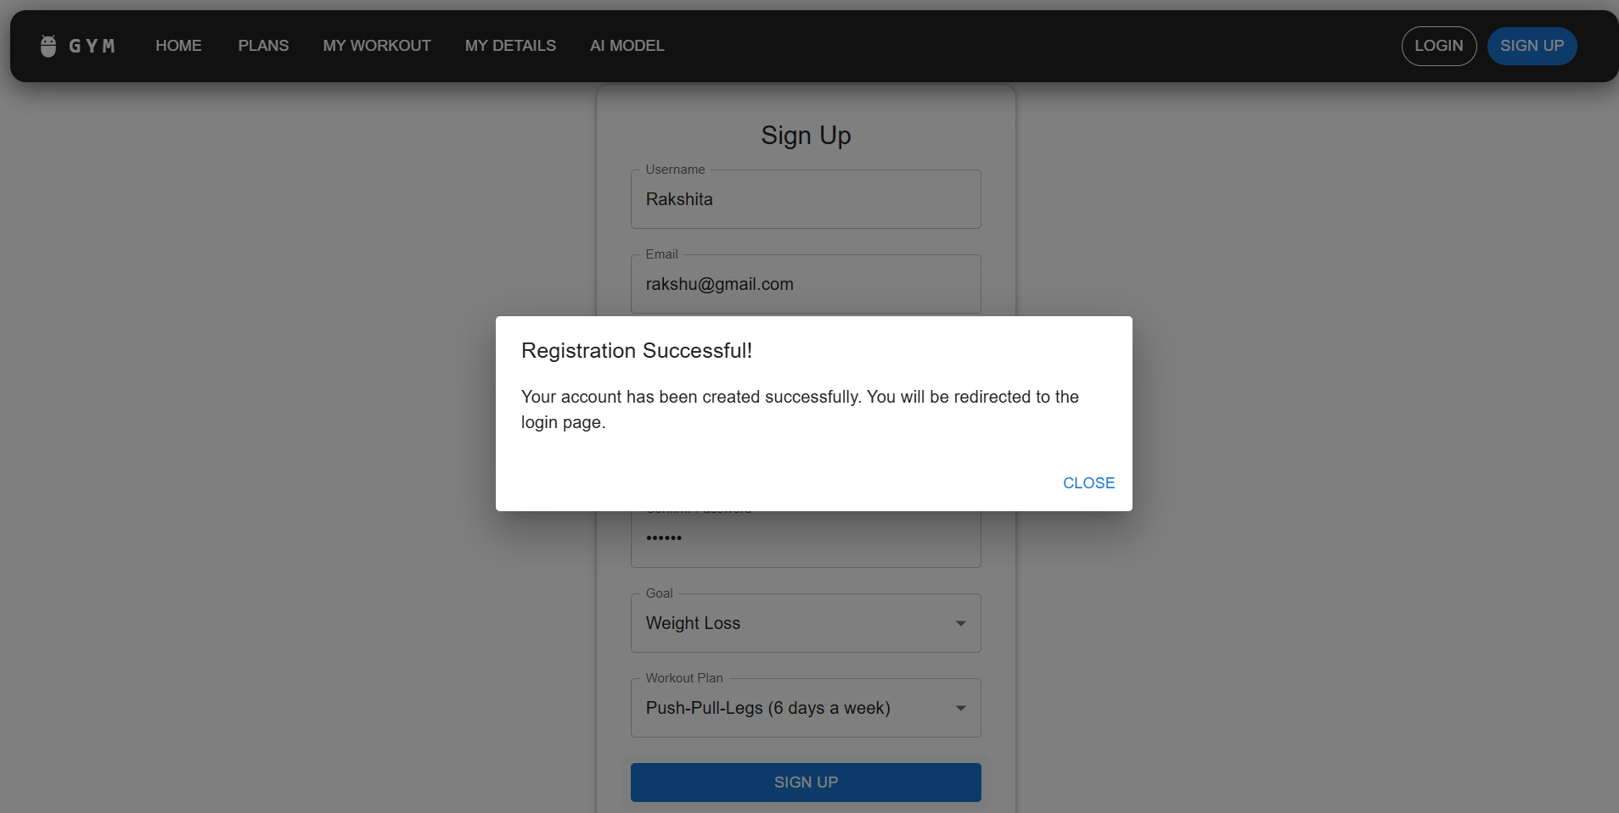

Fig 5.3: Sign In Page

**5.4 login Page:**

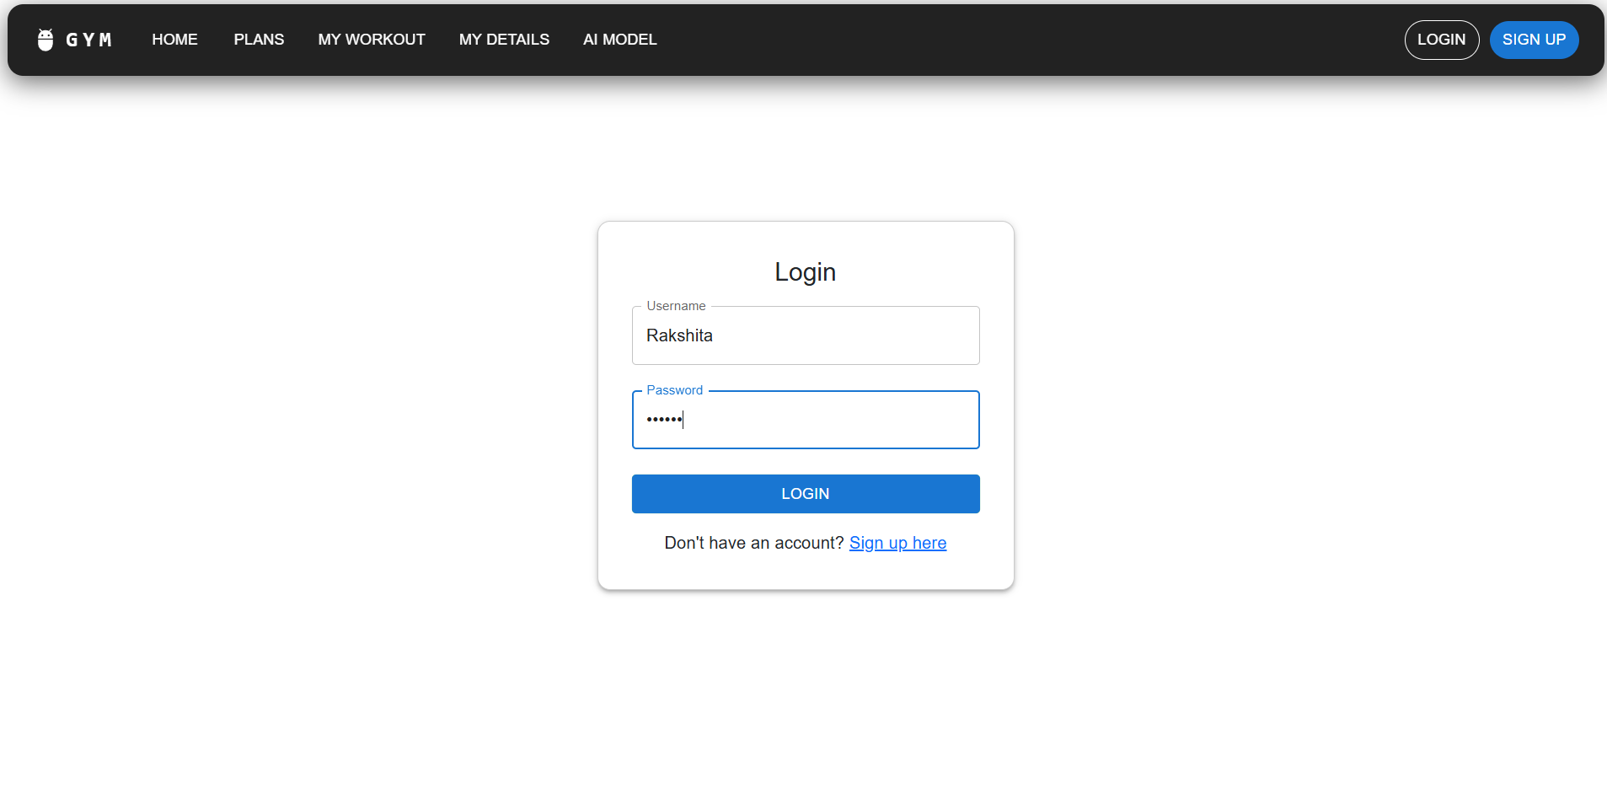

Fig 5.4: **login Page**

**5.5 Profile Page:**

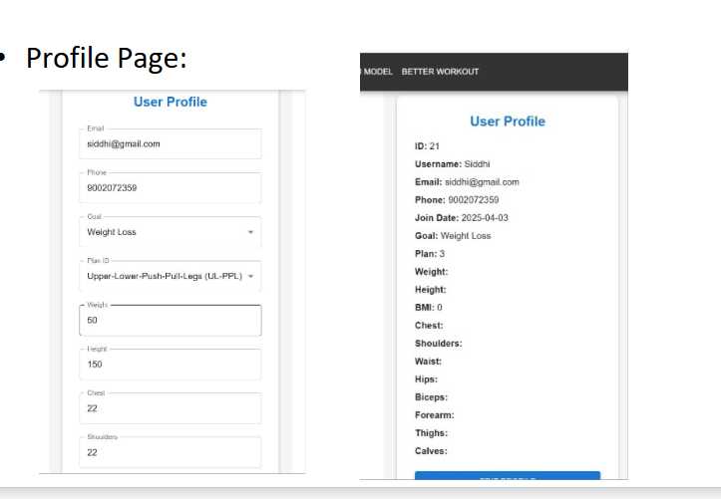

Fig 5.5: Profile Page

**5.6 Exercise Guide:**

This page shows the Exercise Guide section of the Fitness website. It allows users to select an exercise from a dropdown menu to learn how to perform it correctly. In this example, the selected exercise is "calf raise", and a visual illustration is displayed highlighting the muscles targeted (calves). This feature helps users understand proper exercise form and the muscle groups involved.

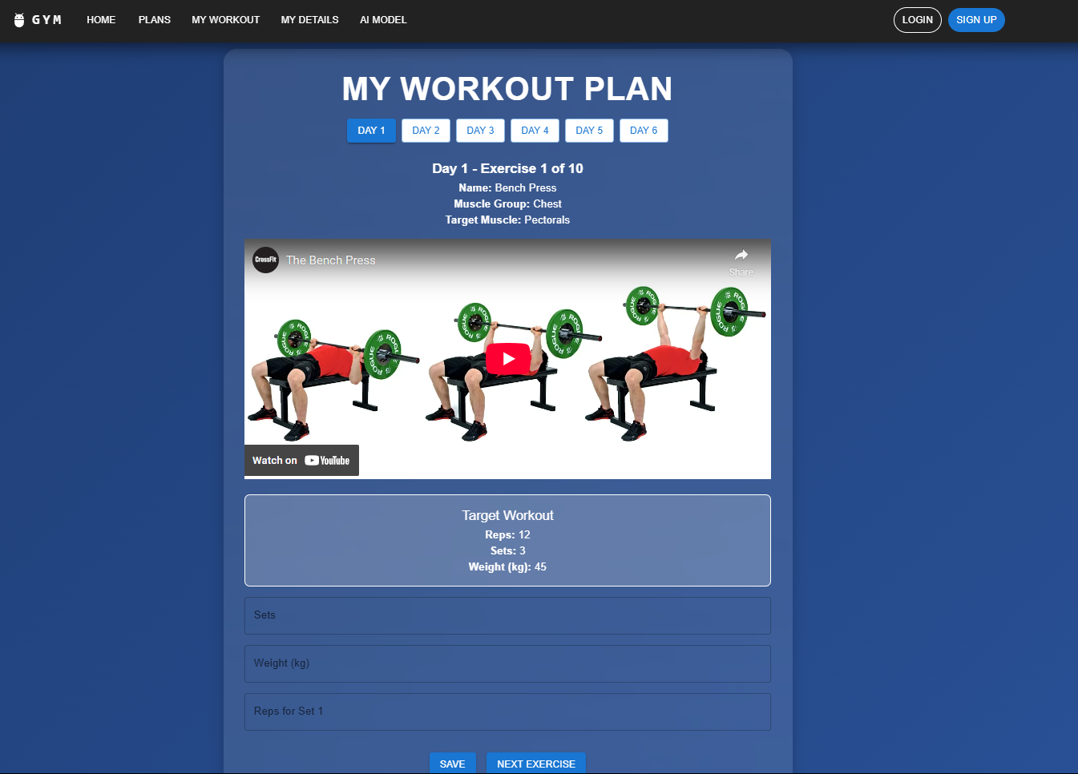

Fig 5.6: Exercise Guide

**Chapter 6**

**Conclusion and Future Scope**

**6.1 Conclusion**The Fitness Tracking System project is an all-encompassing platform aimed at helping users effectively monitor and improve their fitness journey. The system includes a Performance Tracking feature that allows users to assess their fitness progress over time. The Personalized Workout Plans offer customized exercise routines, tailored to individual goals and fitness levels. The Virtual Exercise Demonstrations help users understand proper form and technique, enhancing workout safety and effectiveness. Automated Reminders ensure users stay consistent with their routines, helping to build long-term fitness habits. The Exercise Guide provides in-depth information on a wide range of exercises to ensure proper execution. By integrating these features, the system offers a convenient and comprehensive solution for users looking to achieve their fitness goals and lead healthier, more active lives.

**6.2 Future Scope**The future scope of the Fitness Tracking System includes the addition of more advanced features, such as personalized fitness coaching and progress tracking to provide users with deeper insights into their fitness journey. Future updates could also include integration with wearable fitness devices, allowing real-time data collection for a more accurate analysis of performance. The platform could expand to offer more interactive features, such as video tutorials, community forums, and fitness challenges, to foster greater user engagement and motivation. As technology evolves, the system may incorporate AI-driven workout and meal plan recommendations to deliver even more personalized and dynamic support. Ultimately, as the platform continues to adapt to the latest fitness trends and technologies, it will provide users with the tools they need to meet their health and fitness goals efficiently.

**References**

**1. Tran, V.N., 2015​**

"Barter Online Network",​

   Discusses online platforms for fitness tracking and community engagement, highlighting user motivation factors, May.​

**​**

**2. Lee, J., & Kim, H., 2018, ​**

"Personalized Fitness Tracking",  ​

   Explores the use of AI in personalized fitness recommendations, emphasizing adaptive algorithms for user feedback, June.**​**

**​**

**3. Smith, A., & Jones, R., 2020, ​**

"The Role of Technology in Fitness", ​

   Examines how technology enhances fitness applications, focusing on user engagement and retention strategies, April.